CSE110 Lab1

Clone command

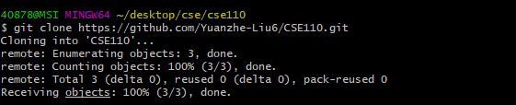

Cd into the repo folder and create a new branch called “add-read-me”, and check out that branch

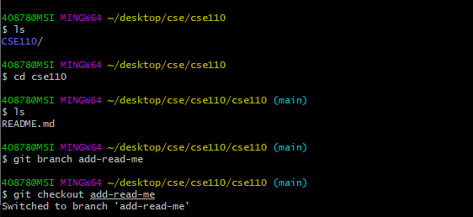

Use Vim to edit README.md



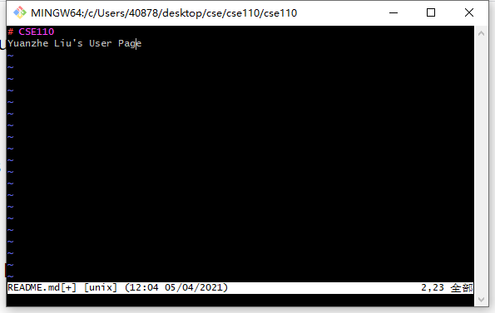

Add the edited file to git



Commit the files with commit message “Update readme file”.

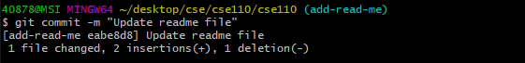

Push the commit to the remote branch.

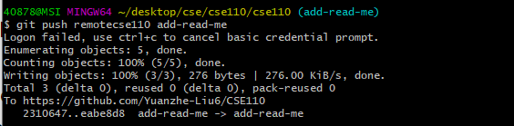

Branches in my git

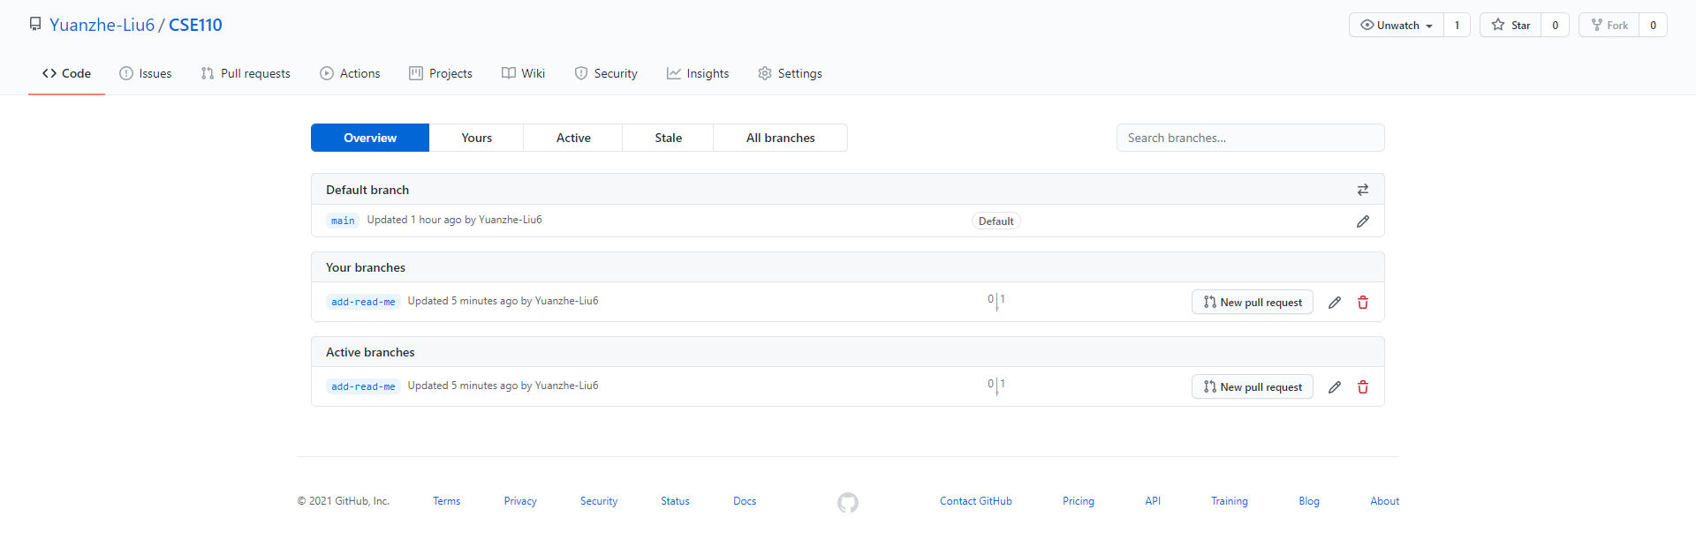

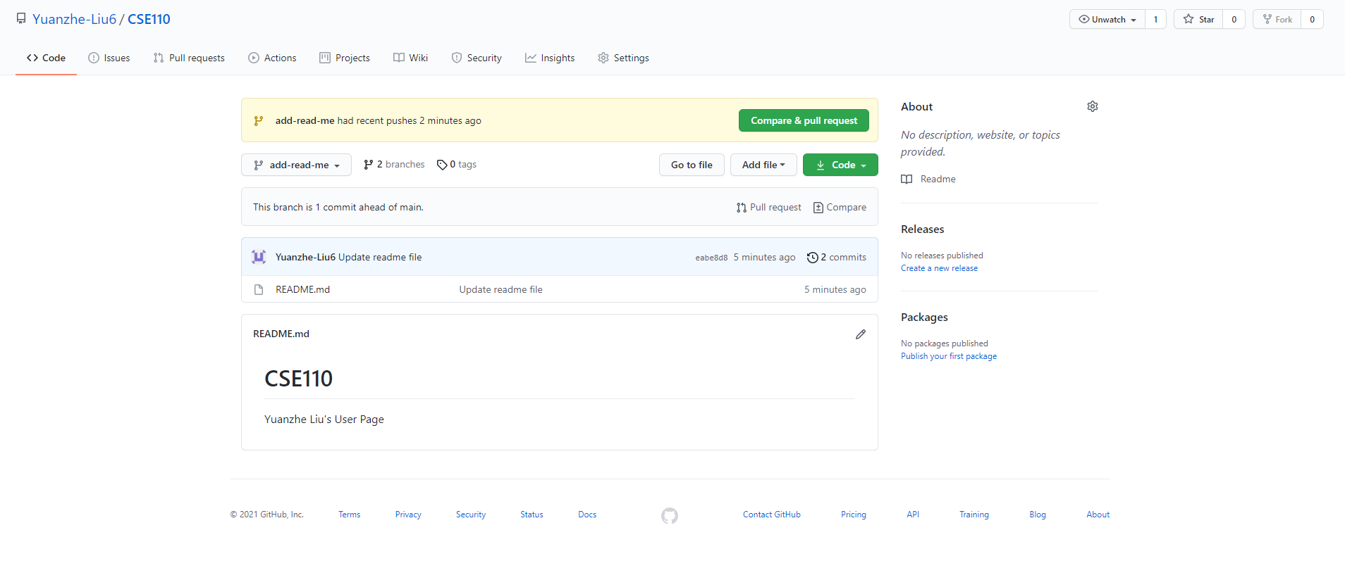

Create branch in vscode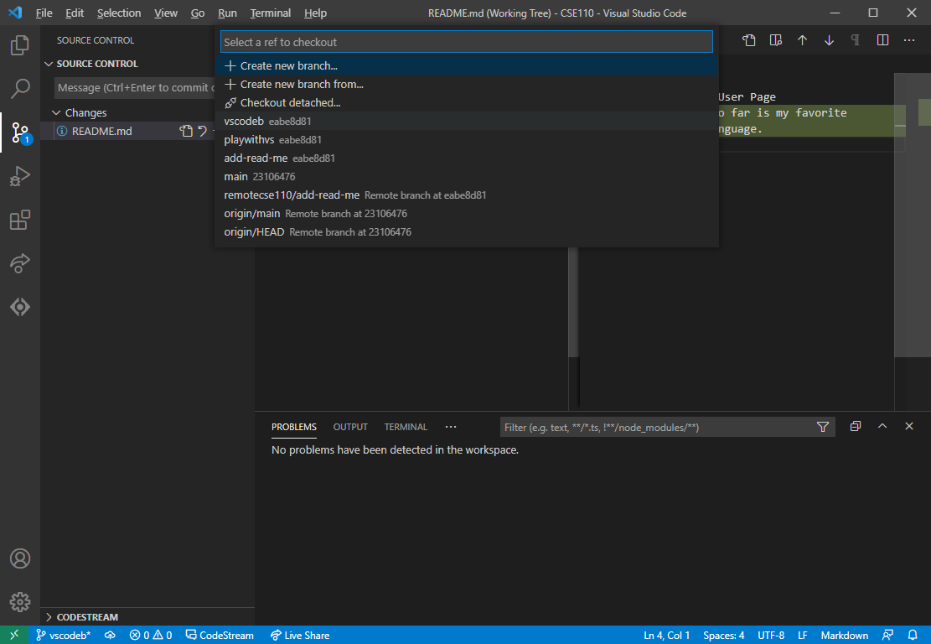

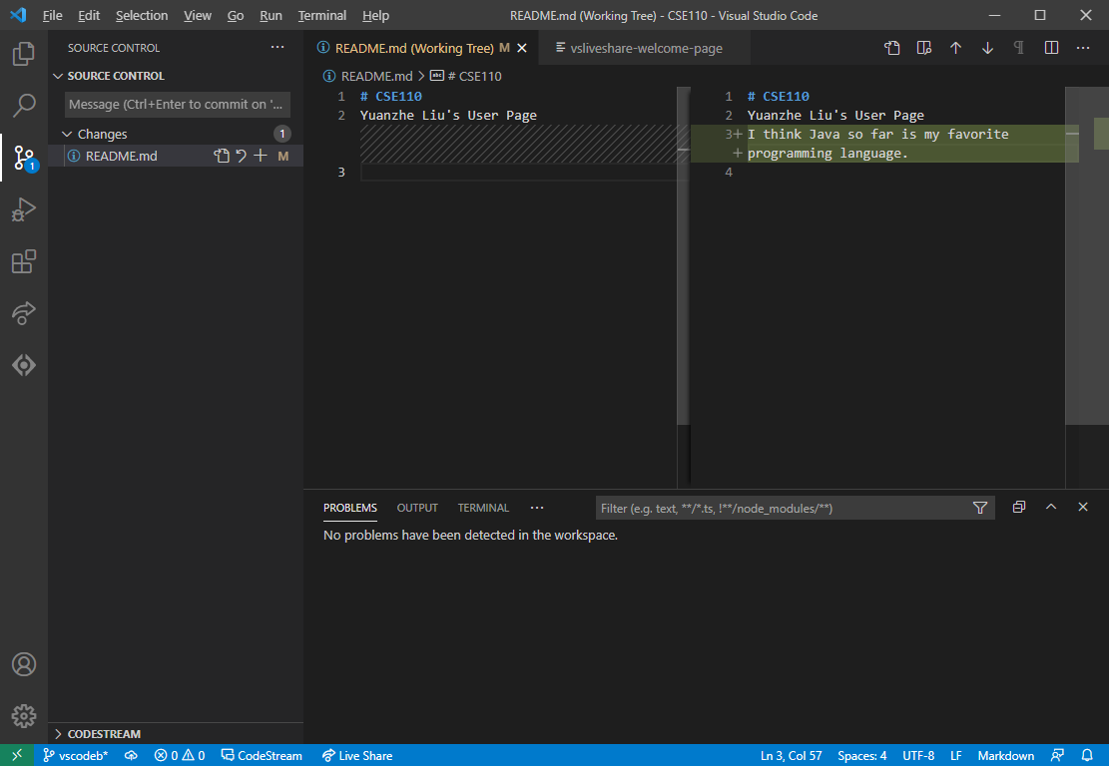

Stage the changes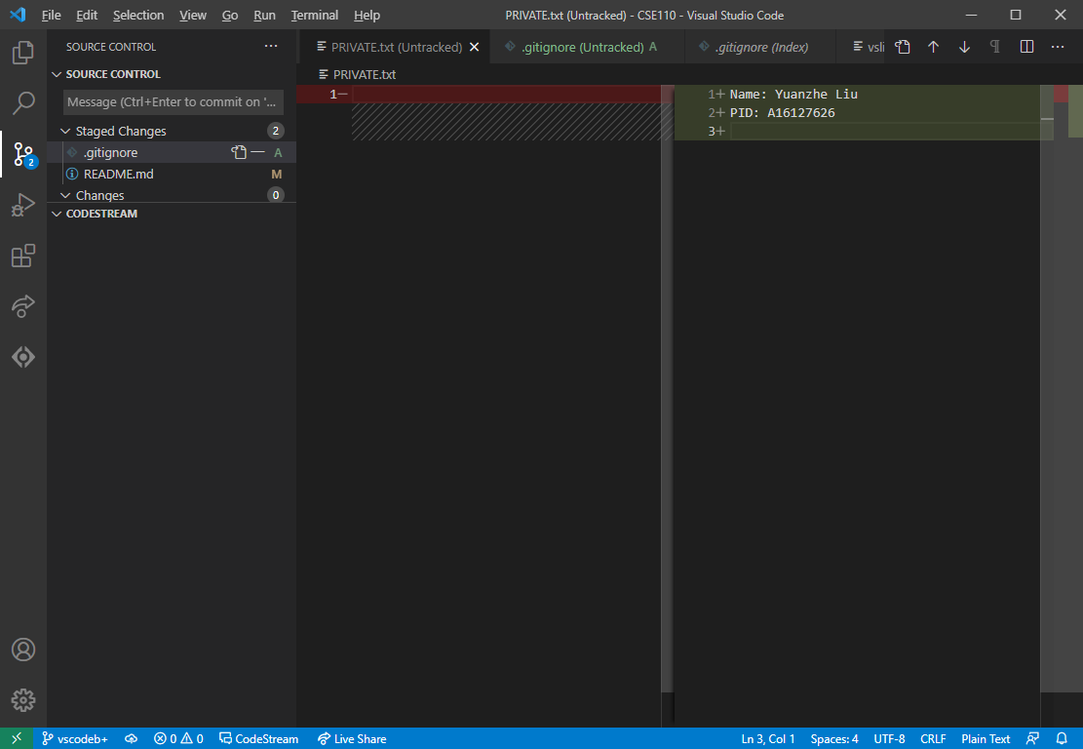

Commit before push

